PRINCETON THEOLOGICAL SEMINARY

Lissette González Sosa:
Alumna Cultivates the Land and the Spirit

Lissette González Sosa has always seen a direct connection between stewardship of the land and those who tend it. At Princeton Theological Seminary, she discovered how best to express that ethos, eventually creating Sanctuary + Seed, in Martinsville, NJ, a worship, retreat, and eco-education center that practices and facilitates stewardship of the self and the earth, restorative spirituality, and contemplative living and working.
“Sanctuary + Seed is an open welcome, inclusive, interfaith community, whose basis is Christian,” Lissette offered. “It’s an ecclesial response to the need for community. This is an ecclesial response to the land, to climate change, to capitalism, and the overuse and commodifying of people and land, and our responsibility as Christians.”
A “cradle and Spanish Presbyterian” and a social worker by trade, Lissette has spent her entire life in passionate service to marginalized individuals and communities, most notably those who grow and produce the food that sustains us, immersing herself in critical issues they face, doing whatever she could to improve conditions for this underserved population.
Today, she puts her multiple degrees from Princeton Theological Seminary to excellent use in a ministry that has created the perfect intersection for her spiritual and theological background paired with a passionate advocacy for the land and its people.
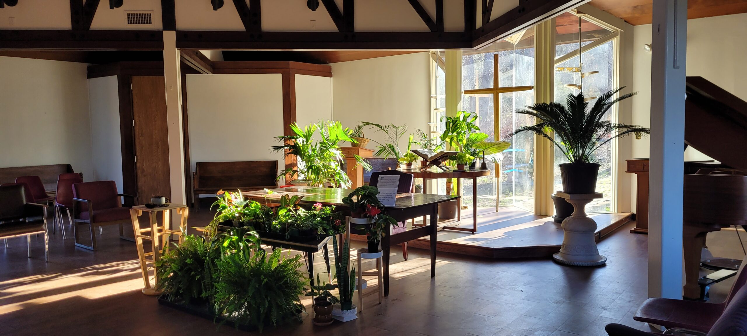

A Legacy of Faith and Service
“I was the Regional Administrator for the National Farmworker Jobs Program at PathStone Corporation, which meant that I was probably on every single farm in the state of New Jersey.” She worked closely with migrant and seasonal farm workers, educating them about their rights while working with growers to provide free pesticide training for workers and whatever resources they might need. “I was immersed in the farm world for many years” before arriving at the Seminary.
Lissette also served as a Case Manager for the Archdiocese of Philadelphia and Youth Director for the First Presbyterian Church of Moorestown, NJ. Even farther back, her parents, along with other Spanish-speaking families, founded Iglesia Hispana Presbiteriana Bet-el, a Spanish Presbyterian church, when she was three.

A Call to Seminary—And an Unexpected Detour
About seven years ago, she was approached to become a Commissioned Ruling Elder (CRE) at a Spanish-speaking mission in Camden, NJ, and she wanted the flexibility of being ordained a pastor, which meant going to Seminary, something her husband Mario strongly urged her to pursue.
However, her life took a drastic turn, and she had to put all those plans on hold when he was diagnosed with brain cancer. While Mario was in remission, she submitted her application to Princeton Seminary.
“My husband was my biggest cheerleader. He said, ‘You need to go to Seminary. You need to be a pastor. You need to do it,’” so she submitted her application. “Then the cancer came back with a vengeance, and he was gone in ten months.”
At the same time, Lissette was caring for her husband, her son-in-law was diagnosed with colon cancer. Both men were in the hospital simultaneously, and Lissette’s granddaughter had celebrated her first birthday. About a year later, her son-in-law passed away as well. Further study was paused to allow her family time to heal. “We needed time to mourn and get our lives back together,” she recalled.
Finally, in 2019, Lissette decided to move forward with her dream of going to Seminary full-time and resubmitted her application. “I loved my time at Princeton Seminary,” she explained. At first, she had designs on becoming a traditional pastor working with immigrant and urban communities “because my heart was there.” Over time, it became clear God had a different path in mind for Lissette, one that perfectly aligned with her gifts.
At Princeton Seminary, “I found myself surrounded by a lot of recent college graduates,” she recalled. “Their experience in the Church led them to say, ‘I want to serve God, but that doesn’t necessarily mean that I want to be a pastor of a church.’ I realized this was a new wave. Something different was happening.” Lissette saw many of her fellow students applying their ministerial skills in unique and innovative ways.
Everything coalesced when she encountered the Farminary at the Seminary, a space where theological education is integrated with small-scale regenerative agriculture to train faith leaders conversant in the areas of ecology, sustainability, and food justice. At that moment, everything clicked for Lissette. “This was my background. I love a good farm,” she stressed.
During her orientation, Lissette listened to Dr. Nate Stucky, Director of the Farminary, speak about discovering a new journey and purpose there and how he decided to bridge farm life with ministry. “He said, ‘Sometimes dreams have to die, like the compost pile that eats away all of what was left over, to start something new.’ Tears were literally streaming down my face as he said that,” she recalled. “This is my calling right here.”

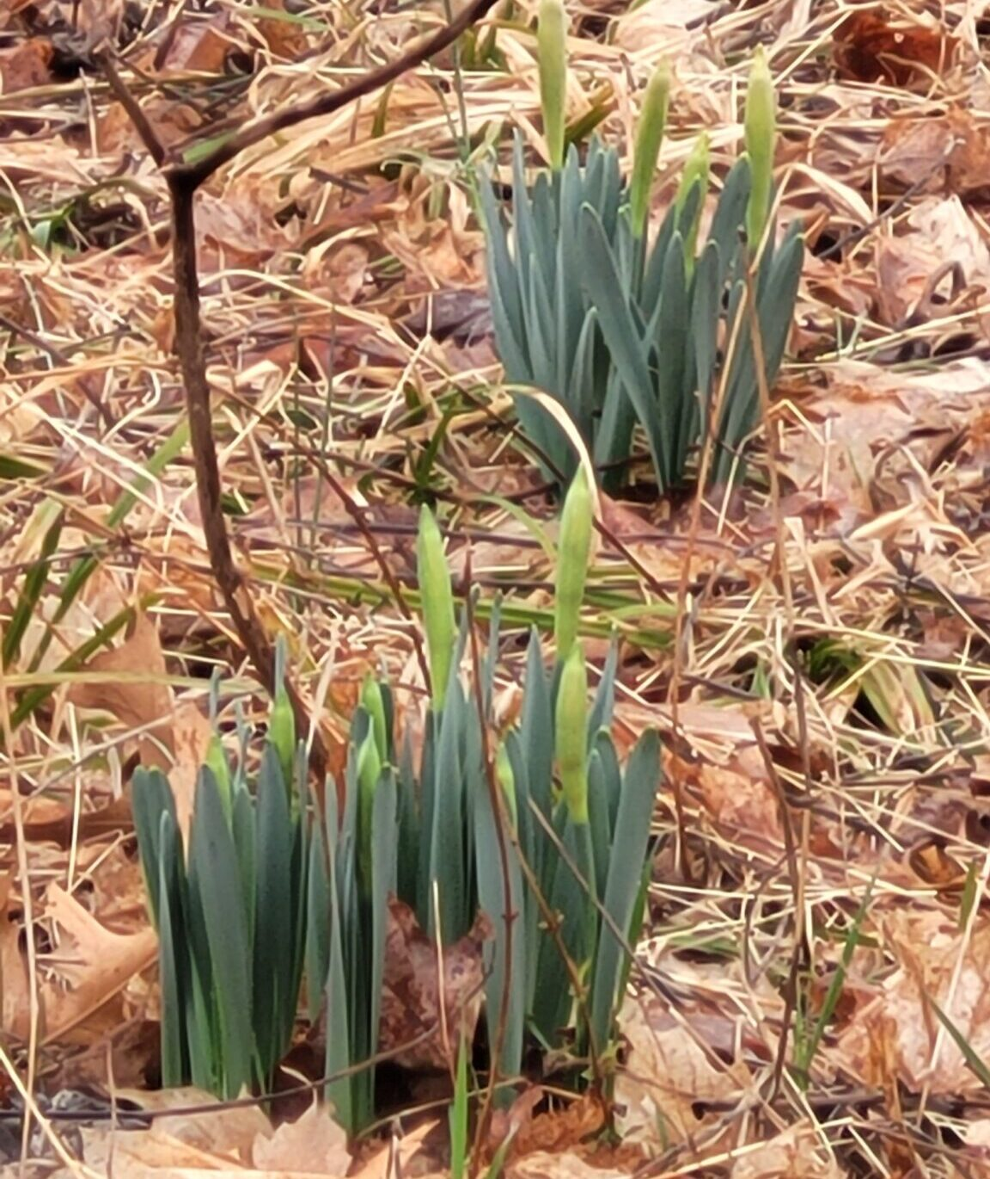
Connecting Land Justice with People Justice
Lissette had the seed of an idea born from the notion that “land justice equaled people justice,” and five years later, it came together with Sanctuary + Seed.
She extended her time at the Seminary by one year and eventually graduated in 2023 with her dual Master of Divinity and Master of Arts of Christian Education and Formation degree, and in 2024 with a Master of Arts in Theology and Ecology.
At Princeton Seminary Lissette started researching and developing ideas for a curriculum churches concerned with understanding land justice could utilize to make their message clear and form an action plan.
“How we treat the land is equal to how we treat the people who tend the land,” she emphasized. “We treat the people who tend the land, who put the food on our table, as the worst pariahs in our community. The commodification of humans is sanctioned by the US H2-A Guestworker Program. It is essentially government indentured servitude and a form of legalized slavery this country has allowed.”
After watching a video in her World Christianity Class about the Coptic Forest Churches of Ethiopia, where trees and gardens surrounded their worship space, symbolizing the Garden of Eden and our connection to creation, Lissette’s idea began to crystalize. “There’s symbiosis. It was all right there for me in that ten-minute video.”
At the Farminary, Lissette wrestled with the idea of how best to serve the migrant and farm worker community and the traditional church. “It’s about this sacred connection of everything that we’ve learned in the Farminary, and how we can make that a reality, and get the church to respond. It’s not just about climate change, but an understanding of justice.”
In her last semester, Lissette was assigned to the Presbyterian Church at Bound Brook for her Pastor as Ethnographer, Coach, and Spiritual Leader course. “This is where I saw all of the work that Bound Brook was doing within their community. I was so impressed and so moved” by the scope of the pantry’s outreach, and by extension, she was impressed with the church and their commitment to the community.
During that semester, Lissette visited the property of the former Christ Presbyterian Church, which was gifted to Bound Brook after it closed. She immediately recognized the potential of the campus, which was inspired by the Farminary. “My mind just exploded. There were so many things I could do with this place.”
Bound Brook entered a two-year discernment period over how to use the land in a way that was consistent with its mission. During that time, Lissette graduated and accepted a position as Director of Christian Education at Bound Brook. At first, Lissette believed she would not fit in at the mostly white parish. All the while, the property and its immense potential was never far from her thoughts.
Bound Brook faced an impasse on what to do with the property. They were going to sell it to another Christian community until Lissette approached them with an idea. “It wasn’t fully formed yet,” but (her idea) included a “Wild Church,” a community garden, and retreat space.”
Lissette explained the Wild Church concept connects people to creation as sacred, inviting them to see and understand the character of the Triune God revealed in the natural world around us. “It is a way of learning God’s deep care for us and for all of creation—human and more-than-human creatures alike. Wild Church invites us to recognize that every portion of creation is sacred, woven together in a sacred rhythm of life, interdependence, and renewal.”

Launching a Bold Vision for Faith and Ecology
Lissette connected with fellow Seminary graduates Candice Lovelace and Esther Chiang, both of whom had experience in the community garden space and the Farminary. “I’m a social worker, not a CEO, so I depended on a team approach to help formulate this plan.” A budget was developed, and our plan was accepted, halting the property’s sale.
Now, the real work began.
A brand kit was developed, staff were hired, and a social media and web presence was created. Lissette wrote and applied for grants, and the site became an official 1001 Worshiping Community with Presbyterian Church USA (PC USA). “We presented at the Presbytery and became an official new church development site.” 1001 New Worshiping Communities is a movement of people who believe in the power of the Holy Spirit to transform lives and communities through the gospel of Jesus Christ.
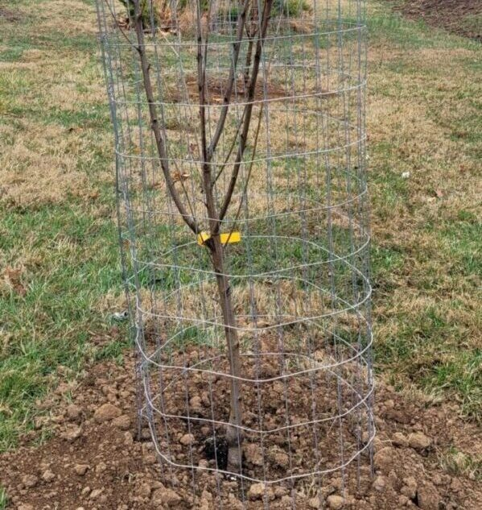
As ordination approached, Lissette was concerned that she was not fulfilling the original mandate of her scholarship. However, the Presbytery officially recognized her position as Executive Director of Sanctuary and Seed as Organizing Pastor and Evangelist, christening the space as a new worship community within PC USA. She was ordained in March with that title. “I think that’s the coolest title ever,” she laughed.

A Space for Healing, Connection, and Faith
Sanctuary + Seed officially opened last summer. Since then, it has attracted a small army of volunteers and community partners who believe in Lissette’s vision. On any given day, volunteers are found painting, building, planting the community gardens, preparing for worship, donating clippings, and getting the word out to the surrounding communities they will serve.
Lissette wants Sanctuary + Seed to be a haven for people of all faiths, as well as non-believers. “People have said, ‘There’s something about this place that calls to me and something I want to learn more about.’ People need to be connected to something sacred and spiritual.”
She added that she views Sanctuary + Seed as a place of rest, healing, and spiritual restoration. “It’s also a space where people are deconstructing their faith, trying to reframe and heal from previous religious experiences that may have harmed them.”
Lissette stressed, “It’s about our place in creation and our place in the whole spectrum of everything. We’re supposed to work together symbiotically as one creation, not to pillage the land, but to work with it, to serve it, and to tend it as we are serving God. For me, Sanctuary + Seed is a place where we can learn about the character of God in this alternative setting and within creation. And we get to see God’s character through how God cares for not only us, but for all the creation, the animals, the insects, the trees, etc.”
Sanctuary + Seed “attracts and invites a lot of different people, but it also attracts pastors and people who go to traditional church but find their spiritual rest here.” She is happy to provide a setting for people to be spiritually nourished and rejuvenated. Lissette also credits her three children, Lisby, Leyla, and Cecily Sosa, as sources of unyielding support and ideas throughout her journey of faith and renewal.
Lissette is hoping Sanctuary + Seed can model for other faith communities a different type of ministry. “I think that’s what people are most excited about because some people don’t want their buildings to close. They might have some money, but they can’t sustain a traditional church, and this is something that they can do with people who are looking for land and looking to do something with God’s creation.”

